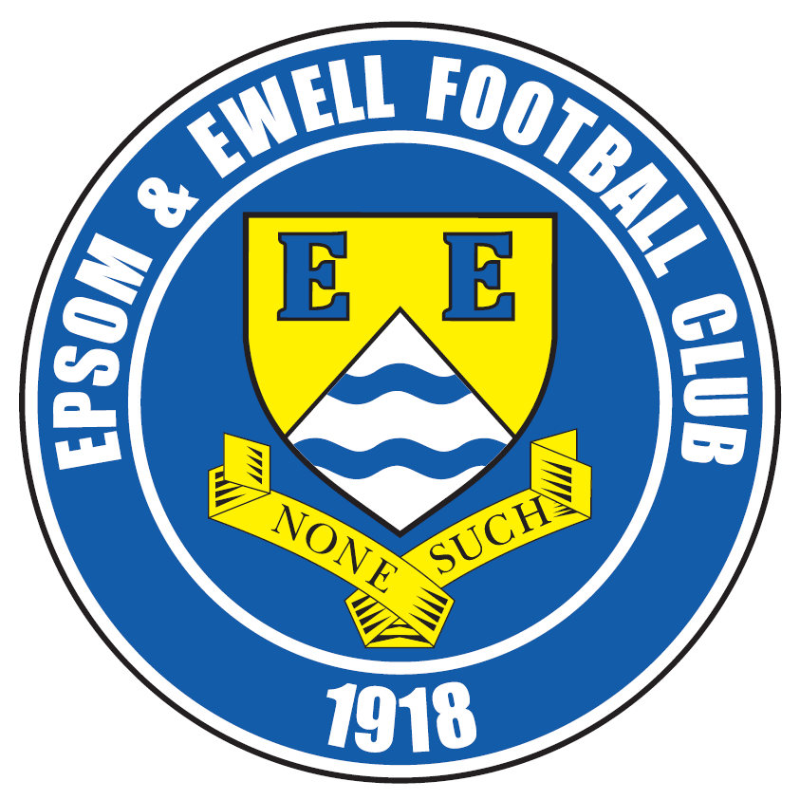 | Epsom & Ewell F.C.  12  v  Camberley Town  Tuesday, 2nd December 2014
For our Surrey Senior Cup tie this evening we welcome the players, officials and supporters of our good friends at Camberley Town, along with today's match officials and of course our own regular supporters.

We will host our visitors once again in February when they return for a League match, but of course have only recently met each other at Krooner Park, where a goal for them just before half time was the difference between our sides.

Right now we are doing everything expected of a team in the middle of the League. We are beating the lower sides, but losing, although narrowly, to the sides above us. A case in point was the Molesey home game ten days ago. If it were not for a lightning start when they led 2-0 after just 8 minutes this would have been a draw, but a super third goal was fired in on the hour mark; an overhead kick from fully twenty yards, while Kyle Hough’s penalty ensured that the two goal difference remained at the end.

We were due to travel to Guildford City on Saturday but the Spectrum pitch surprisingly failed a pitch inspection. Andon that subject, for those who are unaware, Saturday’s game at home to Hanworth Villa is also off as they have a game in the Third Round of the F.A. Vase on Saturday. We wish them well for their home match against Erith & Belvedere.

Our next match is another Cup match, as we travel to Frimley Green in the Third Round of the League Cup. This competition always represents our best chance of success and is a perfectly winnable tie if we play the way we know we can, although a couple of suspensions won’t help our cause.

We then travel to Ash United’s ground for our first meeting with Badshot Lea this season and return here for our return League match with Spelthorne Sports on Tuesday 16th December.

Thank you for following the Salts. The club, Glyn and the boys value your support.

Enjoy the game!

Rich (Richard.c.lambert@gmail.com) on Twitter @EEFCOfficial

Cover photo this week by Gemma Jarman

Kyle Hough watches as Matt Ferdinando’s header flies into the top corner to open the scoring at Mole Valley SCR

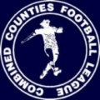
Cherry Red Records
Combined Counties League
Premier Division Table 2014/15
inc 29th November 2014 | P | W | D | L | F | A | Pts | GD | H | A
Cove | 20 | 16 | 3 | 1 | 49 | 24 | 51 | +25 | 7/3 | 0-1
Ashford Town (Mx) | 18 | 13 | 2 | 3 | 45 | 18 | 41 | +27 | 2-4 | 10/1
Windsor | 19 | 13 | 2 | 4 | 49 | 24 | 41 | +25 | 3/1 | 11/4
Camberley Town | 18 | 12 | 3 | 3 | 36 | 12 | 39 | +24 | 7/2 | 0-1
Molesey | 17 | 12 | 0 | 5 | 51 | 18 | 36 | +33 | 1-3 | 28/2
Spelthorne Sports | 17 | 11 | 2 | 4 | 39 | 24 | 35 | +15 | 11/11 | 3-0
Hartley Wintney | 19 | 9 | 3 | 7 | 23 | 29 | 30 | -6 | 21/2 | 1-2
Epsom & Ewell | 20 | 8 | 2 | 10 | 35 | 30 | 26 | +5 | X | X
Colliers Wood United | 19 | 8 | 2 | 9 | 35 | 32 | 26 | +3 | 4/4 | 2-3
Badshot Lea | 21 | 7 | 4 | 10 | 36 | 42 | 25 | -6 | 21/3 | 13/12
Bedfont Sports | 17 | 8 | 1 | 8 | 24 | 30 | 25 | -6 | 0-1 | 2-0
Mole Valley SCR | 21 | 7 | 4 | 10 | 39 | 49 | 25 | -10 | 1-0 | 18/11
Farnham Town | 20 | 6 | 5 | 9 | 37 | 45 | 23 | -8 | 17/1 | 2-0
Chertsey Town | 19 | 7 | 2 | 10 | 30 | 41 | 23 | -11 | 1-2 | 14/3
Raynes Park Vale | 18 | 6 | 4 | 8 | 26 | 30 | 22 | -4 | 0-1 | 27/12
Knaphill | 18 | 6 | 3 | 9 | 22 | 43 | 21 | -21 | 18/4 | 4-1
Frimley Green | 19 | 5 | 4 | 10 | 32 | 45 | 19 | -13 | 0-0 | 25/4
Horley Town | 18 | 4 | 4 | 10 | 34 | 43 | 16 | -9 | 2-2 | 6/4
Westfield | 20 | 4 | 3 | 13 | 23 | 41 | 15 | -18 | 31/1 | 0-4
Guildford City | 19 | 4 | 1 | 14 | 29 | 57 | 13 | -28 | 4-1 | 29/11
Hanworth Villa | 17 | 3 | 2 | 12 | 21 | 38 | 11 | -17 | 6/12 | 5-2

Lucky Day? – 2nd December
Played 10 - Won 8 Drawn 1 Lost 1 - F 23 A 12 - PPG 2.50 - Fantastic!
Club record against Camberley Town
Played 83 - Won 37 Drawn 20 Lost 25 Abandoned 1
F 150 A 111 - PPG 1.58 - Above Average
Last visit
Saturday 5th April 2014 - Lost 0-2 - Combined Counties League

Anthony Panayi
Evening all!

Tonight we host Camberley Town; a side we know very well after losing marginally to them a few weeks ago.

We know their direct style, something we are going to need to be very wary of this evening if we're to progress into the next round.

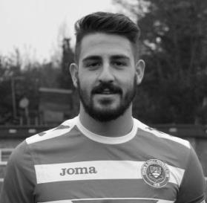
Recently we have found a really positive way of playing, making it hard for sides to break us down. Before a very disappointing defeat to Molesey last week, we have shown signs that yet again we are making the right steps forward in order to climb the table.

As the winter period is well underway all the players would like to thank all the support shown on these not so luxurious afternoons/evenings!

Enjoy the game!

COME ON YOU SALTS!

Ant

Did You Know?
Today is the 2nd December. You probably knew that bit!

However, this date is the most successful in our history with a record of eight wins and a draw from our ten matches played. Last time we played on this date we were at Merland Rise, playing against another team that we hadn’t done too well against in recent times, Chertsey Town.

Still it didn’t stop us beating them 2-1 with a comedy own goal from the Chertsey defender!

Can we keep the record going tonight? We’ll just have to wait and see!

Results and Fixtures
F.A. Vase Second Round – Saturday 22nd November
Eastbourne United | 1-3 | Horley Town
Hanworth Villa | 1-0 | Knaphill
Pagham | 1-2 | Colliers Wood United
Westfield | 1-5 | Tunbridge Wells
Combined Counties League – Saturday 22nd November
Epsom & Ewell | 1-3 | Molesey
Farnham Town | 3-3 | Chertsey Town
Frimley Green | 2-3 | Mole Valley SCR
Hartley Wintney | 0-4 | Cove
Raynes Park Vale | 3-1 | Ashford Town (Mx)
Spelthorne Sports | 6-1 | Guildford City
Windsor | 1-2 | Camberley Town
Combined Counties League – Tuesday 25th November
Ashford Town (Mx) | 2-3 | Windsor
Surrey Senior Cup Second Round – Wednesday 26th November
Leatherhead | 2-1 | Farnham Town
Combined Counties League Cup Second Round – Saturday 29th November
Worcester Park | 1-0 | Chessington & Hook United
Combined Counties League – Saturday 29th November
Camberley Town | 3-1 | Hartley Wintney
Chertsey Town | 3-0 | Westfield
Colliers Wood United | 4-1 | Frimley Green
Cove | 4-3 | Spelthorne Sports
Hanworth Villa | 2-3 | Farnham Town
Knaphill | 3-1 | Horley Town
Mole Valley SCR | 0-4 | Windsor
Molesey | 0-1 | Bedfont Sports
Raynes Park Vale | 1-2 | Badshot Lea
Surrey Senior Cup Second Round – Tuesday 2nd December
Badshot Lea | V | Kingstonian
Epsom & Ewell | V | Camberley Town
Knaphill | V | Colliers Wood United
LIngfield | V | Westfield
Molesey | V | Egham Town
Tooting & Mitcham United | V | Horley Town
Combined Counties League Cup Third Round – Tuesday 2nd December
Windsor | V | Ash United
Results and Fixtures
Combined Counties League – Tuesday 2nd December
Bedfont Sports | V | Raynes Park Vale
Chertsey Town | V | Ashford Town (Mx)
F.A. Vase Third Round – Saturday 6th December
Colliers Wood United | V | Lingfield
Hanworth Villa | V | Erith & Belvedere
Horley Town | V | Greenwich Borough
Combined Counties League – Saturday 6th December
Ashford Town (Mx) | V | Molesey
Farnham Town | V | Knaphill
Frimley Green | V | Spelthorne Sports
Guildford City | V | Mole Valley SCR
Hartley Wintney | V | Raynes Park Vale
Westfield | V | Cove
Windsor | V | Bedfont Sports
Combined Counties League Cup Third Round – Tuesday 9th December
Camberley Town | V | Ashford Town (Mx)
Frimley Green | V | Epsom & Ewell
Combined Counties League – Tuesday 9th December
Bedfont Sports | V | Colliers Wood United
Horley Town | V | Hanworth Villa
Spelthorne Sports | V | Molesey
Combined Counties League Cup Second Round –Wednesday 10th December
Epsom Athletic | V | Banstead Athletic
Combined Counties League Cup Second Round – Saturday 13th December
Alton Town | V | Farnham Town
Combined Counties League – Saturday 13th December
Badshot Lea | V | Epsom & Ewell
Bedfont Sports | V | Guildford City
Camberley Town | V | Chertsey Town
Cove | V | Ashford Town (Mx)
Knaphill | V | Colliers Wood United
Mole Valley SCR | V | Hanworth Villa
Molesey | V | Horley Town
Raynes Park Vale | V | Windsor
Spelthorne Sports | V | Hartley Wintney
Westfield | V | Frimley Green

From behind the goal
Epsom & Ewell 1-3 Molesey
Combined Counties League – Premier Division
Saturday 22nd November 2014

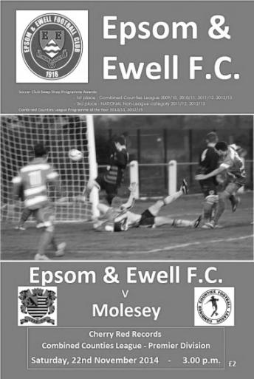
Slow start kills Salts chances of success

Four days after our flying start at Mole Valley it was a case of role reversal at High Road as visiting Molesey raced into a two goal lead of their own, and despite competing at a similar level to their opponents for the remainder of the match we had to settle for an honourable defeat, which might have been closer if not for some very weak decision making from the referee.

It must be said that Molesey are a very good team, but they do moan! From bench to players the constant pressure they put on the official was really pushing the art of gamesmanship to the limit, and the game plan bore fruit early once Sam Robinson picked up his fifth booking of the season as early as the thirteenth minute. Of course, we were already two-nil down by then, having conceded goals in the fifth and the eighth minutes.

Steve Rowe, making his second start since re-joining the club won the ball, but his pass out of defence was then cut out and the ball whipped in low and finished from close range by Jamie Linegar. Three minutes later a striker fell over Rowe's outstretched leg, and while nearby observers said the foul was outside the box, both the referee and assistant were clear in their belief that it was a penalty. Stef Palmer stepped up to beat Michael Eacott from the spot, but only just, as our keeper was unlucky not to keep the shot out.

The remainder of the half was very limited in incidents of note. An Alex McGregor cross gave Matthew Ferdinando the chance and his header was not far away from putting a header into the top corner as he had done on Tuesday, but was just wide after 17 minutes, while it was fully twenty minutes before either team produced another noteworthy effort. After 40 minutes Matt Robinson cut in from the left and his shot hopped a little in front of the visiting keeper Liam Allen but he kept his eye on the ball and held onto it. He then made a superb save right on the half time whistle when Ferdinando sent a great cross in from the right and his effort was met by a fine downward header from Kyle Hough but a combination of good positioning and his legs kept the ball out.

We started the second half well enough but nearly conceded a third when a right wing cross found an incoming Molesey player completely on his own but he was just unable to direct his shot on target and Eacott gathered. Although Dan Dean headed a Sam Robinson corner header just over the bar we went three-nil down in the 59th minute. A hopeful ball wasn't really cleared, but as the ball fell to Palmer with his back to goal he hooked it over his head from twenty yards with the ball going in off the bar and Eacott helpless. If it had been scored in the Premier League, everyone would have been raving over it and although maybe we could have defended the attack better there was no doubting the quality of the strike.

From this point we took possession of a greater share of the game. The introduction of Taylor Smith for McGregor after 63 minutes sparked things a little, although there is nothing like injustice to give the players extra motivation and when a high ball was sent over and hit the hands of a Molesey defender moments later there was a big shout for a penalty. Now there is often a dispute about ball to hand but the hands were above the head and to my mind this was a stonewall penalty but it wasn't given.

Insult was then added to injury after 74 minutes when Smith went to go between two defenders and was taken out by both of them. The referee went to put his whistle to his mouth but then despite being just five yards away from the incident and well positioned, he chose to look at the Assistant who wasn't flagging for anything, probably because he rightly thought the referee was in the better position. As a result of this he chose to give nothing again. It is to our players’ credit that there were no dissent bookings as a result, although from the touchline I might have earned one this week!

As Molesey played for time, again taking full advantage of the official's generosity, we then finally earned a penalty when Hough went around the defender and was brought down in injury time. Although this probably was a correct decision, the two previous appeals were more clear cut than this one and as Hough struck the penalty home with his usual clinical precision you couldn't help wondering whether he would have had a hat trick of penalties on another day.

It must be said that a draw would have been harsh on Molesey who were probably the best side we have played this season. They worked very hard, closing us down at every opportunity and of course the two goal lead gave them the perfect opportunity to express themselves. We were always chasing the game from that point but on another day we might just have got something out of it.

Team: Michael Eacott, James Taylor, Steve Rowe, Anthony Panayi ©, Dan Dean, Matt Farrell, Matt Ferdinando, Sam Robinson, Kyle Hough, Alex McGregor, Matt Robinson

Subs: Taylor Smith for McGregor (63), Matt Tanton for Rowe (73), Sean White for Ferdinando (80)

Club Records - 2nd December
Date | Day | Competition |  | Opponents |  | Scorers
02/12/33 | Sat | London League | A | Finchley | 0-1
02/12/50 | Sat | Surrey Senior Cup  4q replay | A | Hawkers Athletic | 4-3 | S.Faggetter (2), B.Musto, T.Wright
02/12/61 | Sat | Surrey Senior Cup 3q | H | Camberley Town | 6-3 | J.Punter (3), T.Millard, D.Mead, B.Kenyon
02/12/67 | Sat | Athenian League 2 | A | Aveley | 3-2 | J.Eales (2), o.g.
02/12/72 | Sat | Athenian League 2 | A | Hemel Hempstead | 1-1 | B.Jones
02/12/78 | Sat | Surrey Senior Cup 4q | H | Bae Weybridge | 3-1 | S.Delaney, D.Walker, T.McCready
02/12/80 | Tue | Isthmian League 1 | A | Camberley Town | 2-0 | T.Tuite (2)
02/12/95 | Sat | Isthmian League 3 | A | Hornchurch | 1-0 | S.Smith
02/12/97 | Tue | Isthmian League 3 | A | Kingsbury Town | 1-0 | A.Rawlinson
02/12/06 | Sat | Combined Counties Premier Division | H | Chertsey Town | 2-1 | A.Pero, o.g.
Historical Decades
90 years ago – Epsom Town
29/11/24 | Sat | Surrey Senior Cup 1 | H | Weybridge | 1-2 | R.Sperring
80 years ago – Epsom F.C.
01/12/34 | Sat | Friendly | H | Woking | 2-4 | J.Levison, M.Wiggins
70 years ago – War time Epsom Town
02/12/44 | Sat | Surrey Senior Cup 2  1st leg | H | Tooting & Mitcham United | 1-1 | G.Brogdale
60 years ago – Epsom F.C.
27/11/54 | Sat | Corinthian League | H | Hounslow Town | 5-6 | B.Musto (3), B.Avis (2)
50 years ago – Epsom & Ewell
28/11/64 | Sat | Athenian League 1 | A | Wembley | 1-1 | D.Bruce
40 years ago – Epsom & Ewell
30/11/74 | Sat | Surrey Senior League | H | Virginia Water | 0-2
30 years ago – Epsom & Ewell
01/12/84 | Sat | Isthmian League  Premier Division | H | Windsor & Eton | 4-4 | T.Tuite (2), S.Milton, S.Hill
20 years ago – Epsom & Ewell
03/12/94 | Sat | Isthmian League 3 | H | Kingsbury Town | 3-3 | P.Meredith, T.O'Connor, S.Miller
10 years ago – Epsom & Ewell
30/11/04 | Tue | Surrey Senior Cup 2 | A | Woking | 0-4

History Corner – 2nd December
70 years ago this week our wartime Epsom Town side hosted Tooting & Mitcham United in a Surrey Senior Cup tie at West Street. The competition had only restarted the previous season and this match was a repeat of that season’s final which the Terrors had won 3-1.

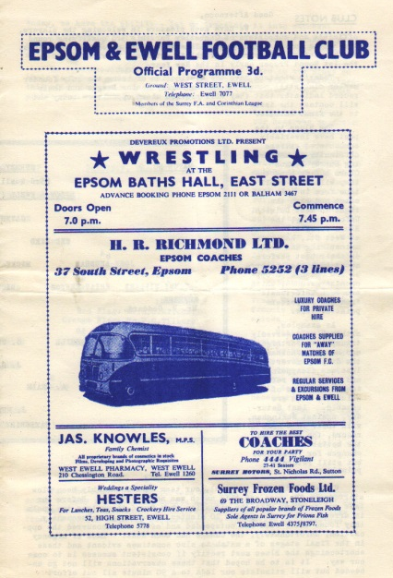
The qualifying rounds were two-legged back then, presumably due to a lack of many competitive fixtures and we were fortunate that the Reserves were off this day as Weller and Stennett both ended up playing. We trailed at half time but Harry Brown saved a penalty in the second half which was key as Gordon Brogdale scored an equaliser to enable us to go into the second leg at Sandy Lane on level terms.

This will be the third occasion that we have played Camberley Town on this day. 53 years ago today Jim Punter scored a hat trick as we knocked them out of the F.A. Cup by six goals to three (see programme pictured) and 34 years ago today two goals from Tommy Tuite earned us all three points in an Isthmian League First Division match at Krooner Park.

60 years ago this week we had a very unusual occurrence as Bobby Musto scored a hat trick for us, yet ended up on the losing side as Hounslow triumphed 6-5 in a Corinthian League match. There was no shame though as Hounslow would actually reach the Semi-Finals of the Amateur Cup this season so it’s fair to say they were a bit warm!

40 years ago this week something even stranger happened. We lost a League match! In fact, this would be the only League match that our 1974/75 title winning side would lose in the League all season as Virginia Water defeated us 2-0 at West Street. We would gain revenge though, winning the return fixture and also winning the League Cup at their expense at the end of the season!

30 years ago this week we had a thrilling 4-4 draw with Windsor & Eton at West Street. The game swung back and forth and came to life in the second half after being 1-1 at the break but regrettably the most memorable parts were our two own goals and their injury time equaliser!

20 years ago this week we were spending our first season of ground sharing at Banstead Athletic and hosted Kingsbury Town in a League match, but we trailed 3-2 and a new substitute Stuart Miller entered the fray. His first touch won us a corner and his second was a goal from that corner as he scored from close range. Miller would prove to be a very popular and hard working striker for us who was plagued with injury. Ironically he still turns out for veterans football aged 41 in Weston super Mare where he now lives!

Camberley Town – History
Not a lot is known about the formation of what is now Camberley Town FC. A copy of a Surrey Senior League Handbook of 1939 refers to Camberley & Yorktown being affiliated to the Surrey F.A. in January 1896, so it is possible that the club formed in 1895.

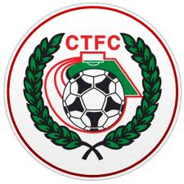
Camberley & Yorktown won their first trophy within two seasons of formation, when in 1897/98 the Club beat Norwood & Selhurst 2-1 in the final of the Surrey Junior Cup. As far as it is known, Camberley & Yorktown initially competed in the Ascot & District League, winning the league title in 1904/05. The Club went on to appear in three Surrey Junior Cup Finals, the first in 1907/08 when Camberley & Yorktown took on Kingston at Woking and were beaten 2-0. In 1908/09 Camberley reached their second final where they lost to Selhurst Park 1-0, but in 1909/10 saw victory at last over Sutton United 2-1.

In 1913/14 Camberley & Yorktown made their first appearances in the F.A. & F.A. Amateur Cups. On September 13th Camberley & Yorktown played host to Sutton United and won 5-3 in their first F.A. Cup match. The first F.A. Amateur Cup game did not go well when soundly beaten 7-0 by the Royal Army Medical Corps. After the Great War, Camberley & Yorktown concentrated their efforts on the Aldershot Senior League. They started 1919/20 well scoring 26 goals in three pre-season friendlies, which included a 15-0 record victory over Royal Engineers, a record that still stands.

In 1922 the Club became founder members of the Surrey Senior League. They celebrated this by moving into the present ground at Krooner Park. The 1930's saw unequalled success as the side won the Surrey Senior League Championship three times in a row. Between 1930/31 and 1932/33 Camberley & Yorktown narrowly missed out on another piece of silverware when they lost 2-1 to Beddington Corner in the Surrey Senior League Charity Cup Final.

The Club reached their 40th anniversary in 1935/36 and celebrated it by reaching the Surrey Senior Cup Final for the first time where they were beaten 3-1 by Wimbledon. Camberley & Yorktown followed up the following season with another appearance in the Surrey Senior League Charity Cup Final, losing 5-0 to Walton on Thames. In 1937/38 they went one further, winning the Surrey Senior League Charity Cup 3-2 over Hersham.

Upon resumption Camberley & Yorktown dropped the Yorktown part of the name and became known as Camberley FC. Krooner Park was not ready for use again by the time the League resumed so the Club started the season at the London Road Recreation Ground. Success was hard to obtain with only a victory in the Surrey Senior Charity Cup in 1952 against Chertsey and a further appearance in the same final three seasons later to show for their efforts in the fifties and sixties.

In 1967 discussions took place between the two senior teams in the town, Camberley Wanderers and Camberley F.C. The two clubs decided to merge and on 2nd June 1967 became Camberley Town F.C. and joined the Isthmian League in 1977. Promotion was achieved in 1979 along with victory in the Final of the Surrey Senior Cup where Leatherhead were beaten 4-1 after extra time.

In 1986 the Club enjoyed their best run in the F.A. Vase reaching the Quarter-Finals before losing to eventual winners Halesowen Town. They won the Aldershot Senior Cup in 1996/97 and 1997/98. 1997/98 also saw Camberley reach the 4th Qualifying Round of the F.A. Cup equalling their best performance since the thirties and they missed out on promotion to Ryman Division 2 on the final day of the season after a great run. In 1998/99 Camberley went one better in the F.A. Cup, reaching the 1st Round Proper for the first time where Brentford knocked them out.

With the disbanding of the Isthmian League Second Division in 2006 Camberley were placed in the Combined Counties League for the 2006-07 season and have since secured their best run of league placings for many years. We also won the League Cup in 2008/09, defeating Worcester Park 3-0 in the Final at Colston Avenue, home of Carshalton Athletic.

Current first team manager Dan Turkington took the helm during 2012-13 season. The club finished in second place in the league in 2014 which was their highest finish in any division since 1979. They also got to the final of the Aldershot Senior Cup but lost 4-3 to Alresford Town at Aldershot Town F.C.

EL Records Premier Challenge Cup
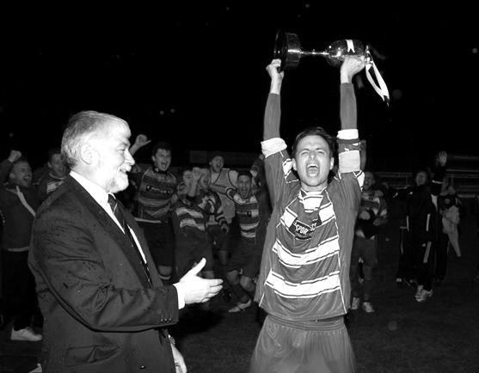
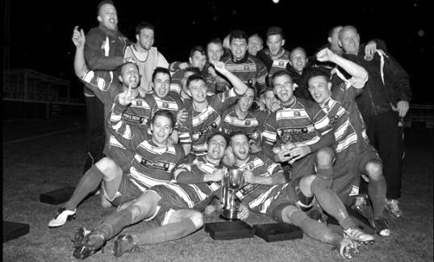
Second Round
Alton Town | 13/12 | Farnham Town
Ashford Town (Mx) | 5-0 | CB Hounslow United
Badshot Lea | 10-2 | Dorking
Bedfont Sports | 1-1+ | Cove
Cove won 4-1 on penalties
Camberley Town | 0-0+ | Molesey
Camberley Town won 3-0 on penalties
Chertsey Town | 0-7 | Windsor
Cobham | w/o Horley | Horley Town
Colliers Wood United | 3-0 | Bedfont & Feltham
Epsom & Ewell | 2-1 | Knaphill
Epsom Athletic | 10/12 | Banstead Athletic
Eversley & California | 2-4 | Ash United
Frimley Green | 1-0+ | Spelthorne Sports
Hanworth Villa | 2-3 | Guildford City
Sheerwater | 1-6 | Mole Valley SCR
Westfield | 4-0 | Farleigh Rovers
Worcester Park | 1-0 | Chessington & Hook United
Third Round
Westfield | 16/12 | Cove
Badshot Lea | 16/12 | Guildford City
Worcester Park | V | Epsom Athletic / Banstead Athletic
Alton Town / Farnham Town | V | Mole Valley SCR
Frimley Green | 9/12 | Epsom & Ewell
Windsor | 2/12 | Ash United
Colliers Wood United | 17/12 | Horley Town
Camberley Town | 9/12 | Ashford Town (Mx)
Centre page for results

Centre page for results

Match and Ball Sponsorships – 2014/15
Opponent | Date | Match Sponsor | Ball Sponsor
Raynes Park Vale | 05/08/14 | Club President - Stella Lamont
Horley Town | 25/08/14 | Epsom & Ewell F.C. Management Committee
Croydon (FAC) | 30/08/14 | Media Officer - Richard Lambert
Frimley Green | 13/09/14 | Dave Gaffney and friends
Guildford City | 30/09/14 | The Jarman family
Mole Valley SCR | 07/10/14 | Mark and Carmel Murphy
Bedfont Sports | 11/10/14 | Epsom & Ewell F.C. Colts
Knaphill (LC) | 14/10/14 | Geoff and Steve Dyke
Ashford Town (Mx) | 18/10/14 | The Building Shop, Bookham
Chertsey Town | 28/10/14 | In Memory of Bob Bexley
Molesey | 22/11/14 | The Cabling Crew 0208 -224 4110
Camberley Town (SSC) | 02/12/14 | In memory of Liz and Doug Burns
Spelthorne Sports | 16/12/14
Windsor | 03/01/15
Hanworth Villa | 13/01/15
Farnham Town | 17/01/15
Westfield | 31/01/15
Camberley Town | 07/02/15
Hartley Wintney | 21/02/15
Cove | 07/03/15
Badshot Lea | 21/03/15
Colliers Wood United | 04/04/15
Knaphill | 18/04/15
For League, League Cup and Surrey Senior Cup Matches:

Match sponsorship - £40.00 Match ball sponsorship - £25.00.
Combined Offer of Match and Match Ball sponsorship for £55.00.

For F.A. Cup and F.A. Vase matches:

Match sponsorship - £50.00 Match ball sponsorship - £30.00.
Combined Offer of Match and Match Ball sponsorship for £65.00.
----------------------------------------------------------------------------------------------------------------------------
Sponsorship includes

Admission, programmes, advertising (if required) and hospitality.

If you are interested, just speak to a Committee Member, you know where we are!
Alternatively, drop me an email at: richard.c.lambert@gmail.com

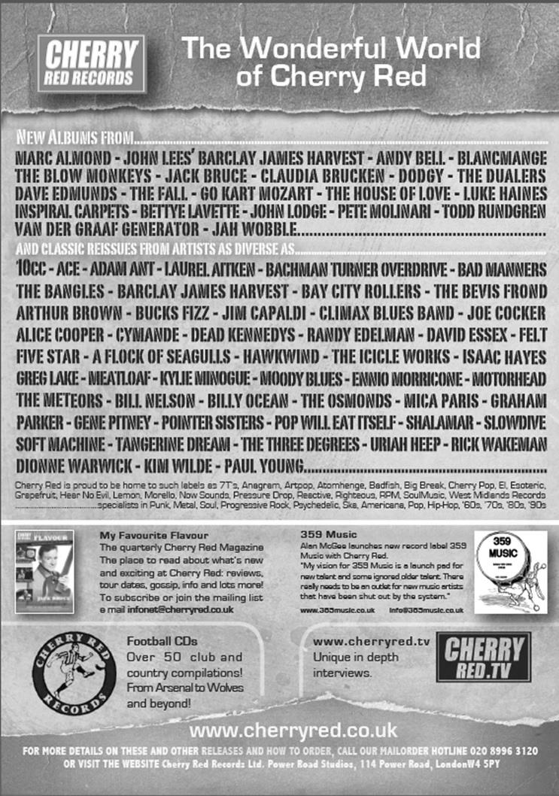

Player Sponsorship
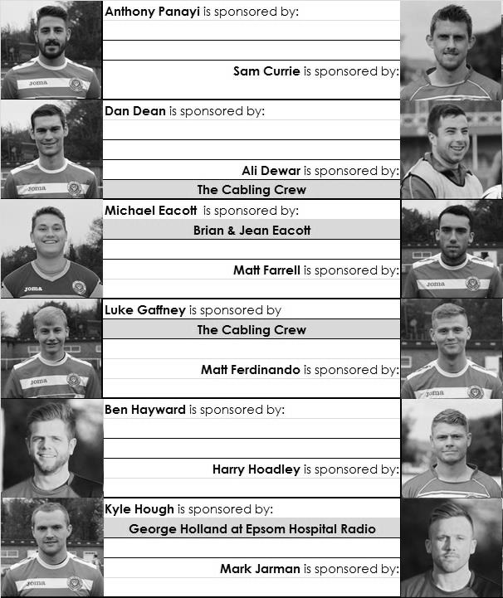

Here is the latest list showing all of the players and Management available for sponsorship. Sponsorship costs £40 so if you want to help the club, the player and get your name in the programme for the season, just let us know before they go!

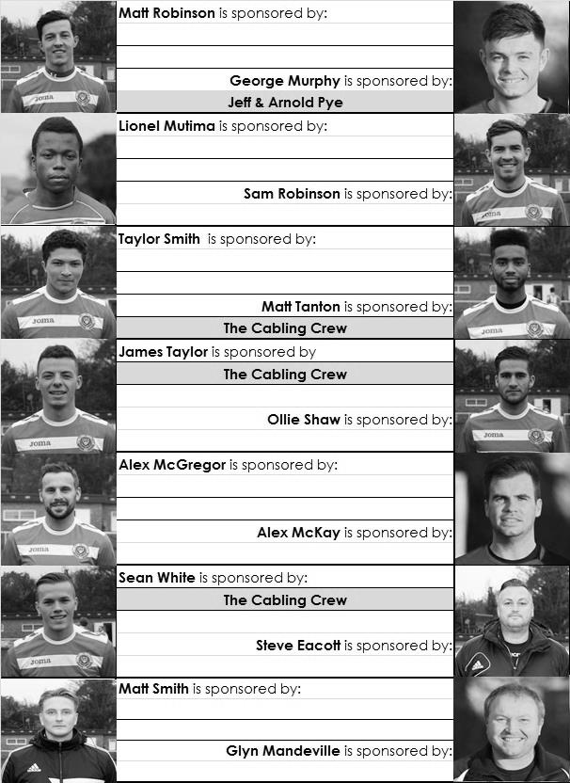

Every Opponent A-Z
Over the years we have played many, many different opponents. Exactly how many is a difficult question, as it all depends on your definition. Are Camberley & Yorktown different to Camberley Town, or are Epsom Town different to Epsom F.C. or Epsom & Ewell F.C.?

In my analysis I have classed them as the same team, and will work through them all from A to Z. Some we have played many times, whilst others we have met maybe just once or twice. Enjoy!


Marlow: Played 20 - W6 D3 L11 - F30 A47 - PPG - 1.05 - Poor

The Alfred Davis Memorial Ground contains one of the oldest and most picturesque grand stands as you will see from the picture here. It has watched over the club for many decades as they are a very old club.

Our first meeting was just over 50 years ago in September 1964 when we were drawn together in the F.A. Cup and romped to a 7-1 win over there aided by four goals from Bill MacKay.

In fairness we were a division higher than them, but our first ever relegation at the end of the season ensured that our next meetings would be League ones. Still, it didn’t stop us completing a League double over them; 4-0 in October 1965 on their first visit to West Street and 4-2 on New Year’s Day 1966 back in Buckinghamshire.

In 1966/67 we were a better team under the stewardship of Player / Manager Tony Williams, however we crashed 7-2 over there and were held to a goalless draw in the return match, played on a Good Friday in front of over 300; our largest attendance for a few years.

We were getting into the dark years at Epsom, and with the departure of Williams, results worsened. Our sum total from the next eight matches was a goalless draw in January 1969, which was the first match ever watched by our long-serving and much missed friend and supporter Chris Henry.

Back then though a goalless draw was a good result for us and it was a blessing in disguise when Marlow were promoted in 1971!

Following our drop to the Surrey Senior League and subsequent return to the Athenian League we met again as equals for the 1976/77 where this time it was our turn to record a double; Gerry O’Rourke scoring twice in our 4-1 win at West Street in September 1976 which followed a 2-0 win there less than two weeks previously on the August Bank Holiday Monday.

We didn’t meet again for another twenty-two years when we were drawn together in the Isthmian League Associate Members Trophy Quarter-Final at Merland Rise. They were a Division Two side and were no doubt favourites but we defeated them 2-1 with goals from Kevin Webb and Chris Wood, becoming the fourth of five higher division teams we would beat on our way to the Final that year.

However, they would get their revenge three seasons later when they edged past us 2-1 in an F.A. Vase Third Round replay at Marlow that could have gone either way. We were unfortunate not to defeat them in the first match but had two clear penalties denied and were held 1-1 after extra time.

Following reorganisation in 2002 we were promoted into Division One South and the next season Marlow dropped down to join us so once more we were League equals. However, this was a disastrous season for us and we crashed 3-0 at home before a pivotal match in Buckinghamshire was destroyed by gale force wind and a sending off for Darren Beale. Despite going into the match on a two game winning run, the 4-1 defeat dropped us back below Corinthian Casuals and never to return.

Marlow have been down to Step Five themselves in recent seasons but as Hellenic League Champions in 2013 they made the move back up to the Southern League where they remain. It is a fitting standard of football for the old stand to witness.

McLaren Sports: see Petter Sports

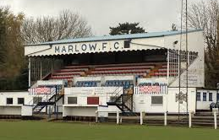
Merstham: see next instalment

Merton: Played 2 - W2 D0 L0 - F10 A3 - PPG - 3.00 - Perfect

Merton FC were, and indeed remain members of the Southern Amateur League, playing in the old days at the John Innes Recreation Ground in Motspur Park and since the early nineties at the Sir Joseph Hood Recreation Ground in the same town. We met them twice in the thirties, both in Amateur Cup ties and both at West Street, winning both, 2-0 in November 1931 and 4-1 in October 1934. On both occasions we went on to reach the final stages of the competition so maybe they were a good omen for us!

First Eleven Appearances - (max 25 inc Molesey)
Name | Debut | 2014/15 |  |  |  | Career Totals
Name | Debut | App | Sub | Total | Goals | App | Sub | Total | Goals
BROWN Oshane* | 30/08/2014 | 2 | 0 | 2 | 0 | 2 | 0 | 2 | 0
CURRIE Sam | 04/08/2012 | 2 | 0 | 2 | 0 | 96 | 5 | 101 | 2
DEAN Dan | 02/08/2014 | 21 | 1 | 22 | 0 | 21 | 1 | 22 | 0
DEWAR Ali | 29/10/2011 | 5 | 2 | 7 | 3 | 55 | 31 | 86 | 10
DOUGLIN Karl* | 03/08/2013 | 1 | 0 | 1 | 1 | 41 | 3 | 44 | 14
DOWNS Carl* | 17/09/2011 | 4 | 1 | 5 | 0 | 94 | 13 | 107 | 2
EACOTT Michael | 02/08/2014 | 23 | 0 | 23 | 0 | 23 | 0 | 23 | 0
FARRELL Matt | 02/08/2014 | 24 | 1 | 25 | 2 | 24 | 1 | 25 | 2
FERDINANDO Matt | 20/09/2014 | 12 | 3 | 15 | 2 | 12 | 3 | 15 | 2
GAFFNEY Luke | 16/08/2014 | 10 | 1 | 11 | 0 | 10 | 1 | 11 | 0
HARPER Tommy* | 15/04/2014 | 1 | 0 | 1 | 0 | 2 | 1 | 3 | 0
HAYWARD Ben | 07/03/2007 | 5 | 0 | 5 | 0 | 241 | 28 | 269 | 18
HOADLEY Harry | 15/04/2014 | 6 | 1 | 7 | 0 | 7 | 1 | 8 | 0
HOUGH Kyle | 14/08/2007 | 21 | 1 | 22 | 10 | 275 | 13 | 288 | 147
JARMAN Mark | 08/08/2009 | 5 | 5 | 10 | 0 | 136 | 51 | 187 | 76
MARVELL Dale | 15/01/2000 | 11 | 5 | 16 | 5 | 261 | 45 | 306 | 85
MCGREGOR Alex | 08/08/2009 | 4 | 0 | 4 | 0 | 161 | 54 | 215 | 26
MCKAY Alex | 08/08/2009 | 1 | 3 | 4 | 0 | 66 | 25 | 91 | 7
MURPHY George | 28/03/2013 | 17 | 1 | 18 | 1 | 58 | 5 | 63 | 3
MUTIMA Lionel | 05/08/2014 | 4 | 2 | 6 | 0 | 4 | 2 | 6 | 0
NELMES Elliott* | 05/08/2014 | 2 | 0 | 2 | 0 | 2 | 0 | 2 | 0
PANAYI Anthony | 14/11/2010 | 17 | 1 | 18 | 0 | 144 | 15 | 159 | 4
ROBINSON Matt | 01/12/2012 | 8 | 1 | 9 | 0 | 9 | 4 | 13 | 1
ROBINSON Sam | 22/10/2011 | 15 | 1 | 16 | 6 | 39 | 4 | 43 | 11
ROWE Steve | 27/08/2011 | 2 | 0 | 2 | 0 | 7 | 1 | 8 | 0
SHAW Ollie | 20/09/2014 | 0 | 10 | 10 | 0 | 0 | 10 | 10 | 0
SMITH Taylor | 02/08/2014 | 13 | 2 | 15 | 7 | 13 | 2 | 15 | 7
TANTON Matt | 02/08/2014 | 15 | 3 | 18 | 1 | 15 | 3 | 18 | 1
TAYLOR James | 26/08/2013 | 18 | 1 | 19 | 1 | 35 | 7 | 42 | 2
VAN GELDER Julian* | 12/09/2006 | 0 | 1 | 1 | 0 | 0 | 2 | 2 | 0
WHITE Sean | 02/08/2014 | 6 | 12 | 18 | 3 | 6 | 12 | 18 | 3
Own Goal |  |  |  |  | 1
* Player has left the club

Surrey Senior Cup
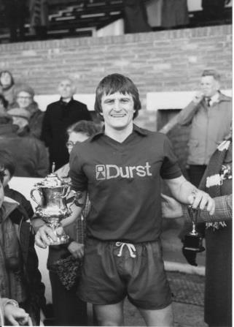

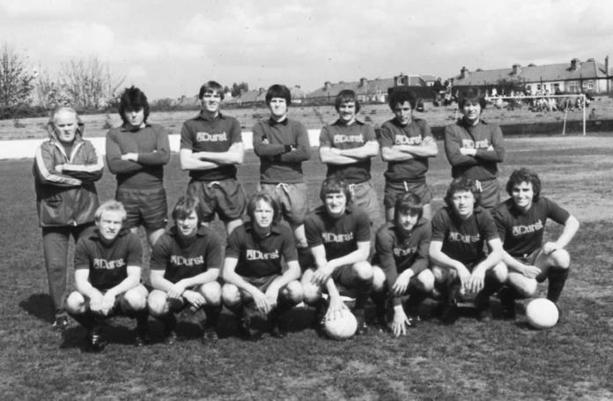
First Round
Carshalton Athletic | 1-2 | Egham Town
Croydon | 0-0+ | Colliers Wood United
Colliers Wood United won 4-3 on penalties
Merstham | 2-1 | Whyteleafe
Raynes Park Vale | 2-0 | Chertsey Town
South Park | 2-1 | Guildford City
Second Round
Lingfield | 2/12 | Westfield
Redhill | 2-1 | Raynes Park Vale
Game played at Raynes Park Vale
AFC Wimbledon | V | Chipstead
Godalming Town | 2-4 | Mole Valley SCR
Knaphill | 2/12 | Colliers Wood United
Metropolitan Police | 1-0 | Walton & Hersham
Epsom & Ewell | 2/12 | Camberley Town
Leatherhead | 2-1 | Farnham Town
Merstham | 3-1 | Beckenham Town
Molesey | 2/12 | Egham Town
South Park | 2/12 | Sutton United
Walton Casuals | 1-2 | Corinthian Casuals
Badshot Lea | 2/12 | Kingstonian
Dorking Wanderers | 9-0 | Frimley Green
Tooting & Mitcham United | 2/12 | Horley Town
Woking | 0-3 | Ashford Town (Mx)

F.A. Vase
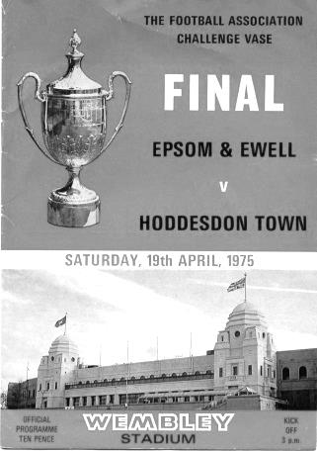
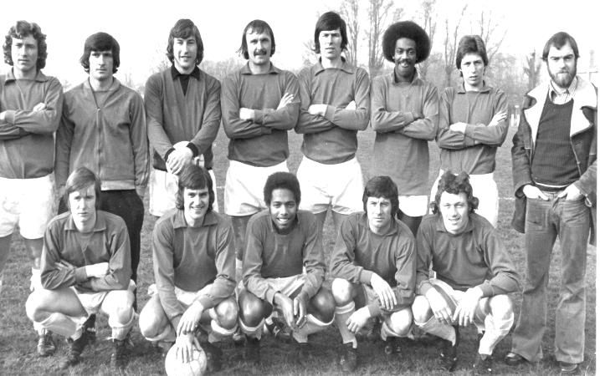
First Round Proper – 1st November
Ashford Town (Mx) | 2-3 | Loxwood
Chertsey Town | 1-2 | Horley Town
Chessington & Hook United | 2-1+ | Camberley Town
Colliers Wood United | 4-3+ | Ringmer
Farnham Town | 3-3+ | Abingdon United
Abingdon United | Replay 5-1 | Farnham Town
Horsham YMCA | 3-1 | Bedfont Sports
Lingfield | 5-1 | Epsom & Ewell
Littlehampton Town | 4-2+ | Guildford City
Lordswood | 0-1 | Knaphill
Pagham | 2-1 | Spelthorne Sports
Raynes Park Vale | 1-3 | Westfield
Windsor | 1-4 | Highworth Town
Second Round Proper – 22nd November
Eastbourne United | 1-3 | Horley Town
Hanworth Villa | 1-0 | Knaphill
Pagham | 1-2 | Colliers Wood United
Westfield | 1-5 | Tunbridge Wells
Third Round Proper – 6th December
Colliers Wood United | V | Lingfield
Hanworth Villa | V | Erith & Belvedere
Horley Town | V | Greenwich Borough

Salts Super Six Predictor
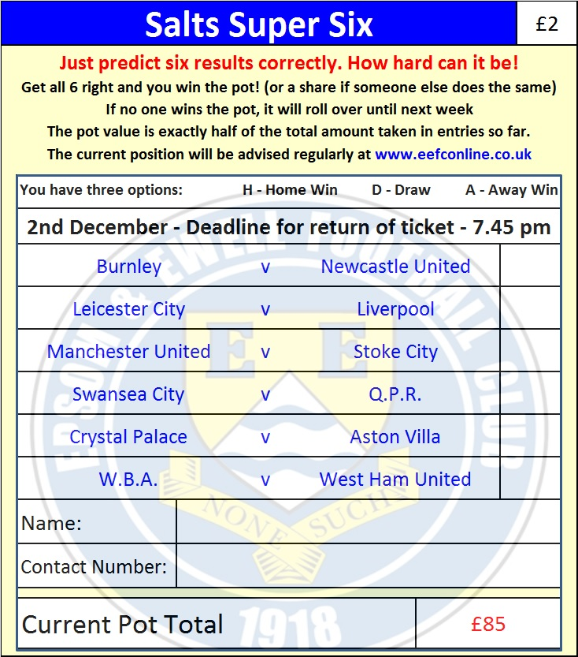
The Salts Super Six Predictor is live again and the deadline is tonight!

The competition is easy to play and you don’t even have to be at the game! To win, you simply need to predict the results of six matches correctly from the three options, fill in the form and make sure it is back with one of our distributors before the deadline on the ticket. Today’s is shown here.

If you are a club regular, you just need to place your name on the sheet, although if you aren’t, then we’ll need a contact number from you too. We will announce any winners on the website within three working days, so don’t worry, we won’t miss you!

The prize pot is currently £85 but will go up, if unclaimed, by the cost of 50% of all the sold tickets. In other words, if we sell 100 tickets before the deadline, and the pot isn’t won, then the next prize will be £185! You’ll always know the pot size before you enter.

Please note that if there is more than one winner, the prize pot would be shared by the number of winners. All you need to do now is have a go, as many times as you like!

Good luck!

Surrey Senior Cup – Second Round
Tuesday, 2nd December 2014 - Kick-off 7.30 p.m.
Epsom and Ewell  (Royal Blue & White hoops) | V |  | Camberley Town  (Red and White Stripes)
 | NUMBERS
Michael Eacott |  |  | Craig Bradshaw
James Taylor |  |  | Matthew Humphrey
Matt Tanton |  |  | Carl Garstang
Anthony Panayi |  |  | Daniel Jewell
George Murphy |  |  | Doug Ford
Dan Dean |  |  | Dan Band
Matt Ferdinando |  |  | Nick Sowden
Matt Farrell |  |  | Sam Slater
Taylor Smith |  |  | Perry Coles
Kyle Hough |  |  | Matthew Bunyan
Sam Robinson |  |  | Jamie Hoppitt
Alex McGregor |  |  | Brad Smith
Matt Robinson |  |  | Dave Hill
Sean White |  |  | Emmanuel Quarshie
Luke Gaffney |  |  | Dean Greenwood
Ollie Shaw |  |  | Joe Wilson
Ben Hayward
Ali Dewar
Alex McKay
Steve Rowe
Glyn Mandeville | MANAGER |  | Dan Turkington
Matt Smith | ASSISTANT
Steve Eacott / Alex McKay | COACHES |  | Dean Greenwood / Sam Rafique
Ken Jones | PHYSIO |  | Gary Mist
REFEREE: D.Bandara (Sutton)
ASSISTANTS: C.Smith (East Grinstead), R.Hailstone (Ash)
Today’s Match and Match Ball are sponsored
in memory of Liz and Doug Burns

OUR NEXT VISITORS TO HIGH ROAD
Spelthorne Sports
Tuesday 16th December 2014 - Kick-off 7.45 p.m.
Combined Counties League – Premier Division

